Manual

Contents

Introduction 1

Installation 1

Add Timeline 2

Edit Timeline 2

Delete Timeline 3

Add Event with duration 3

Add Event without duration 4

Modify Event 5

Delete Event 7

Close Timeline 7

Save Timeline 8

Open Timeline 8

About the Application 9

Manual 9

Exit Application 9

# Introduction

*Greetings!*

Welcome to the manual for the software Timeline Manager. The Timeline manager is a program that creates timelines and events to your choosing, you can even choose your own picture to add to an event.

Here you will find how to setup the software properly and to get started with making timelines, making events and much more fun activities!

# Installation

To start using the Timeline Manager, you will need two things:

1. Java Runtime Environment (JRE)
2. Timeline Manager (jar file)

## Java Runtime Environment (JRE)

To get the JRE, go to this link: <http://www.oracle.com/technetwork/java/javase/downloads/jre8-downloads-2133155.html> and choose the ‘Accept License Agreement’- button, then look for whatever operating system* you are running on and click on the link which is located on the right column. From there, open the file that was downloaded and follow the instructions.

*If you are not aware of which operating system you are running on, there is usually a label on your computer, or check the information within your computer settings.

## Timeline Manager (jar file)

The Timeline Manager should have come with the manual. Simply choose where you want to keep it on your computer. Then just open it and enjoy!

# Add Timeline

To create a new timeline, (1) click on the ‘File’ button on the navigation bar located in the top left corner. (2) There you will find the ‘New’ button, while hovering over it with your mouse you will see ‘Timeline’. (3) Click on ‘Timeline’ and a new window will appear. 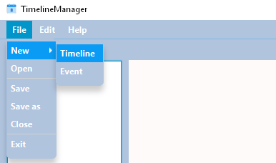

(4) Next, in the new window choose what you want your timeline to be named (the title) and description start date and end date. (5) The last step is to click the ‘Create’ button and you are set. If you for some reason don’t want to create the timeline, just (6) click on the ‘Cancel’ button.

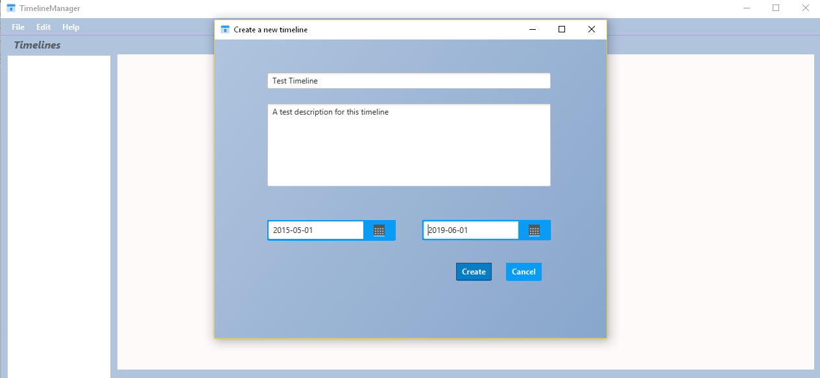

# Edit Timeline

To start editing your active timeline, (1) click on the ‘Edit’ button on the navigation bar located in the top left corner. (2) Next, click on the ‘Timeline’ button and then the (3) ‘Update Timeline’ button. Now a new window should appear. 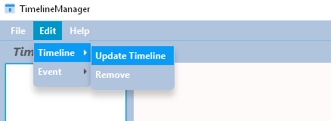

(4) In the new window you can choose what properties you want to edit. When you feel like you are satisfied, you can go ahead and (5) click on the ‘Edit’ button. If you feel like you don’t want to change it and you have already written something else, just (6) click on the ‘Cancel’ button and it will be just as before.

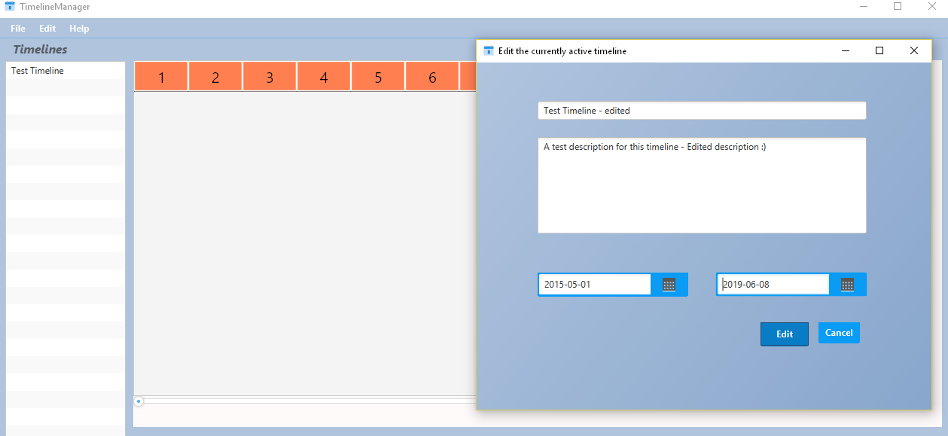

# Delete Timeline

To delete a timeline, (1) click on the ‘Edit’ button, (2) then the ‘Timeline’ and then (3) ‘Remove’. The software will ask you to confirm the removal with a small box.

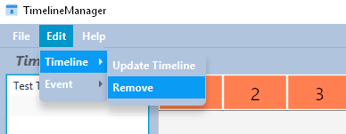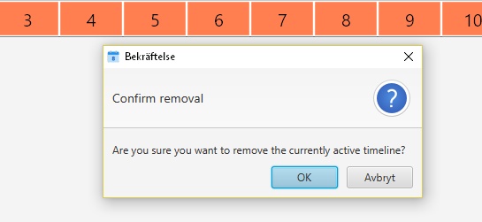

# Add Event with duration

To create a new event, (1) click on the ‘File’ button on the navigation bar located in the top left corner. (2) There you will find the ‘New’ button, while hovering over it with your mouse you will see ‘Event’. (3) Click on ‘Event’ and a new window will appear. 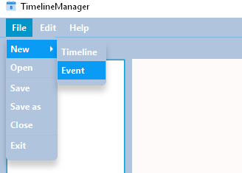

(4) Next, in the new window choose what you want your event to be named (the title) and description, picture, start date, end date, start time and end time. (5) The last step is to click the ‘Create’ button and you are set.

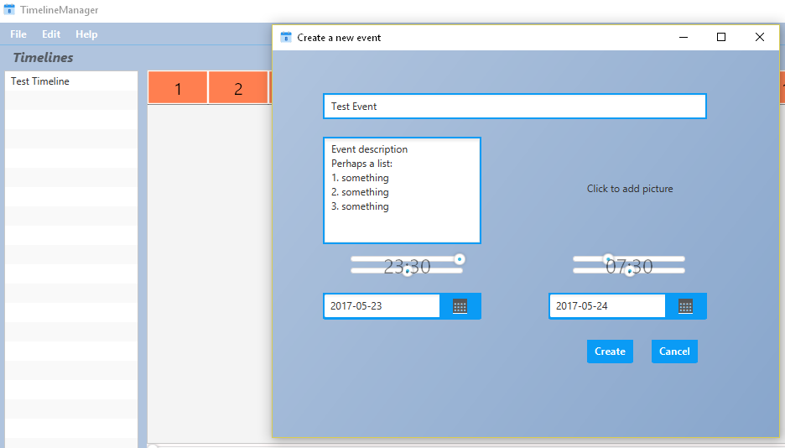

# Add Event without duration

To create a new event, (1) click on the ‘File’ button on the navigation bar located in the top left corner. (2) There you will find the ‘New’ button, while hovering over it with your mouse you will see ‘Event’. (3) Click on ‘Event’ and a new window will appear.



(4) Next, in the new window choose what you want your event to be named (the title) and description, picture, start date, end date and start time. (5) The last step is to click the ‘Create’ button and you are set.

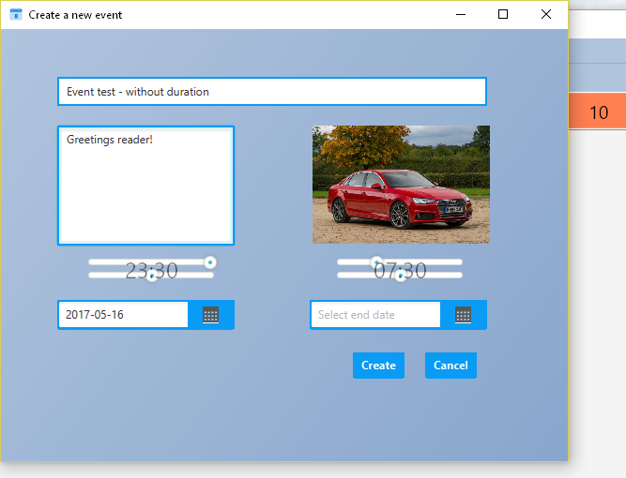

# Modify Event

To start editing your event, (1) click on the ‘Edit’ button on the navigation bar located in the top left corner. (2) Next, click on the ‘Event’ button and then the (3) ‘Update Event’ button. Now a new window should appear with a list of events, if the list is long you can also search for the event in question with the search bar at the top, choose your event and a new window should appear with the event properties.

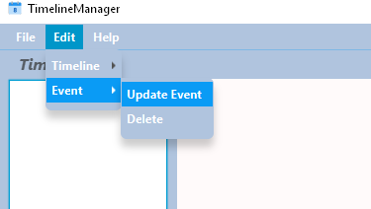

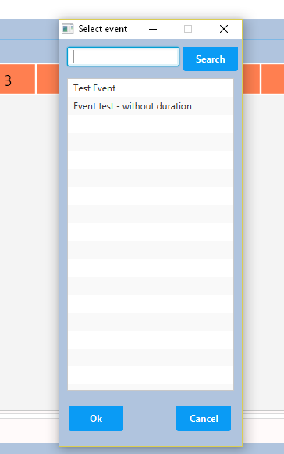

(4) In the new window you can choose what properties you want to edit. When you feel like you are satisfied, you can go ahead and (5) click on the ‘Change’ button. If you feel like you don’t want to change it and you have already written something else, just (6) click on the ‘Cancel’ button and it will be just as before.

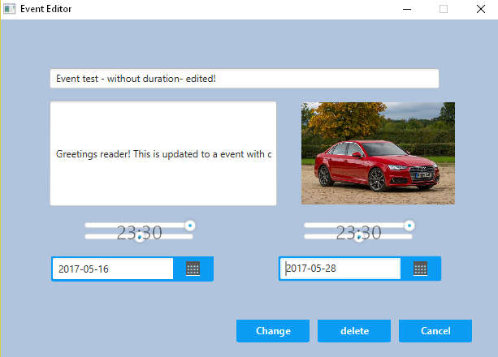

# Delete Event

To delete an event (1) click on the ‘Edit’ button, then the (2) ‘Event’ button and then the (3) ‘Remove’ button. A new window with a list with events will appear, (4) choose your event and in the new bigger window, you’re able to edit and delete that event. The software will ask you to confirm the removal.

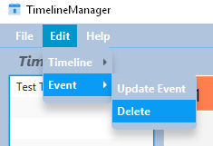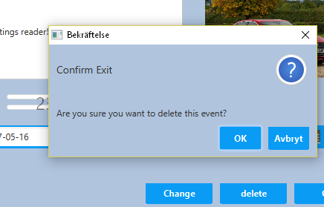

# Close Timeline

To close the timeline and leave the main window blank, (1) click on the ‘File’ button, (2) then the ‘Close’ button.

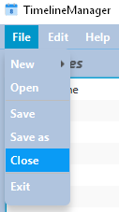

# Save Timeline

To save the timeline so that you can open it again later on, (1) click on the ‘File’ button, (2) then the ‘Save’ button.

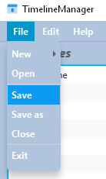

# Open Timeline

To open a saved timeline, (1) click the ‘File’ button, (2) then the ‘Open’ button, (3) then find the name of your timeline and (4) click on ‘Open’.

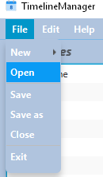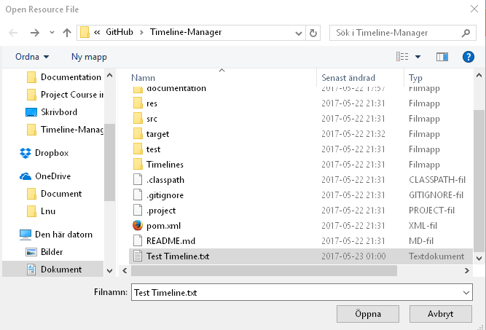

# About the Application

To know more about the application and the developers behind it, (1) click on the ‘Help’ and (2) then the ‘About’ button.

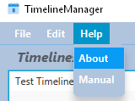

# Manual

To find me, the manual, (1) click on the ‘Help’ button, (2) then the ‘Manual’ button.

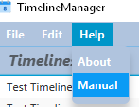

# Exit Application

To exit the software, (1) click on the ‘File’ button and (2) then the ‘Exit’ button.

